Anirban Das (001910501077)

BCSE-II

Q1.

CODE:

//printing an integer using pointer and pointer to ponter

#include<stdio.h>

int main(){

int x;

printf("Enter an integer: ");

scanf("%d",&x);

int *pt1;

pt1=&x;

int **pt2;

pt2=&pt1;

printf("Value of x from pointer: %d\n",*pt1);

printf("Value of x from pointer to pointer: %d\n",*(*pt2));

return 0;

}

OUTPUT:

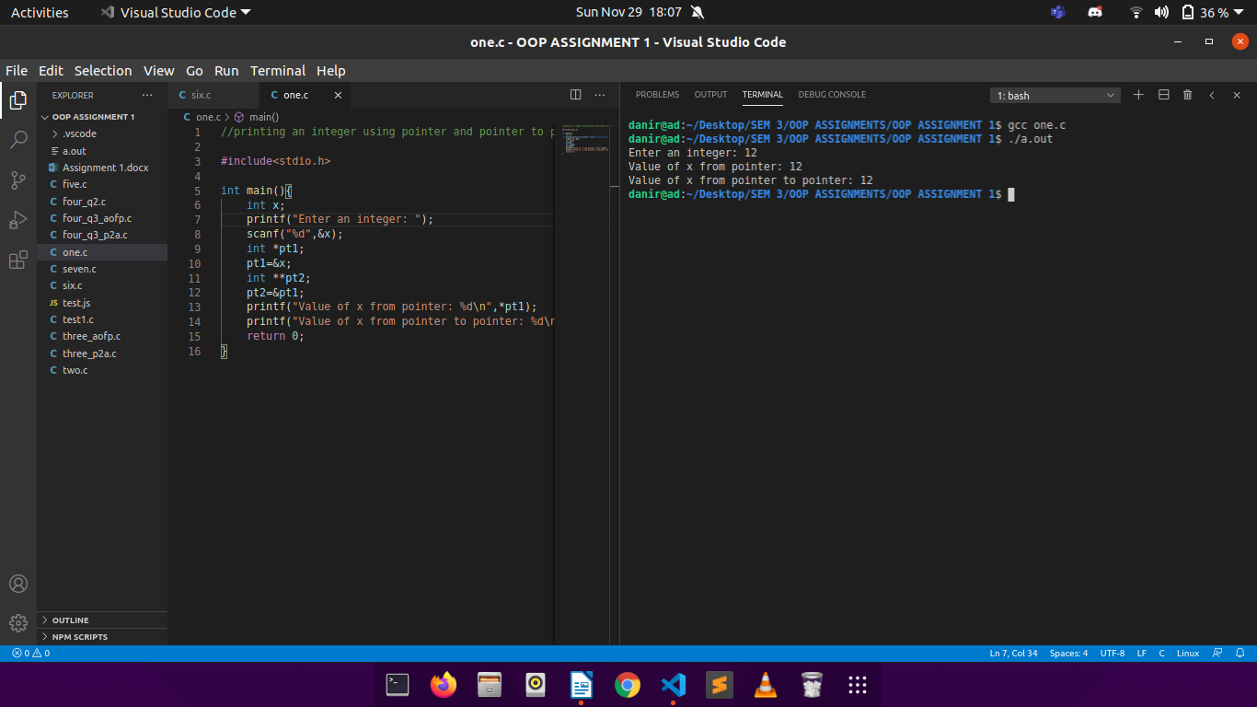

Q2.

CODE:

//implementing 1-D array using single pointer

#include<stdio.h>

#include<stdlib.h>

int main(){

int n,i;

printf("Enter array size: ");

scanf("%d\n",&n);

int *a;

a=(int *)malloc(n*sizeof(int));

printf("Enter the values in array:\n");

for(i=0;i<n;i++){

scanf("%d",a+i);

}

printf("The 1-D array looks like:\n");

for(i=0;i<n;i++){

printf("%d ",*(a+i));

}

printf("\n");

free(a);

return 0;

}

OUTPUT:

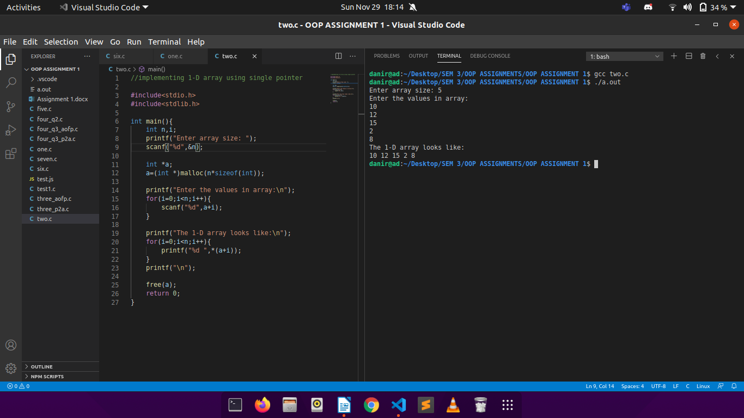

Q3a.

CODE:

//implementing 2-D array using array of pointers

#include<stdio.h>

#include<stdlib.h>

int main(){

int r,c,i,j;

printf("Enter number of rows: ");

scanf("%d",&r);

printf("Enter number of columns: ");

scanf("%d",&c);

int* a[r];

printf("\nEnter the elements of 2D array:\n");

for(i=0;i<r;i++){

a[i]=(int *)malloc(c*sizeof(int));

for(j=0;j<c;j++)

scanf("%d",*(a+i) + j);

}

printf("\nThe 2D array looks like this:\n");

for(i=0;i<r;i++){

for(j=0;j<c;j++)

printf("%d ",*(*(a+i) + j));

printf("\n");

}

for(i=0;i<r;i++){

free(a[i]);

}

return 0;

}

OUTPUT:

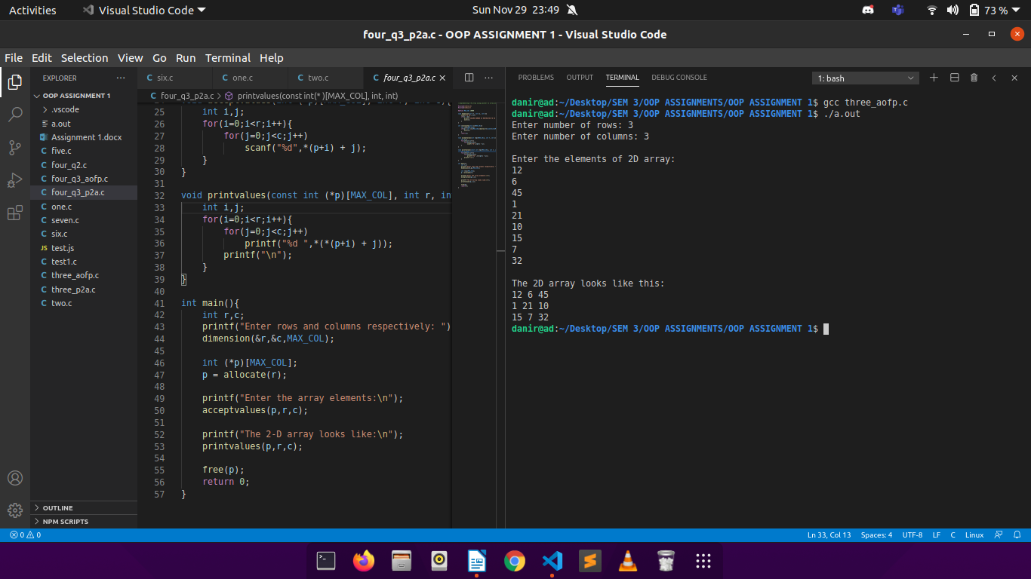

Q3b.

CODE:

//implementing 2-D array using pointer to array

#include<stdio.h>

#include<stdlib.h>

int main(){

int r,c,i,j;

printf("Enter number of rows: ");

scanf("%d",&r);

printf("Enter number of columns: ");

scanf("%d",&c);

int (*p)[c];

p=(int (*)[])malloc(r*sizeof(int [c]));

printf("\nEnter the elements of 2D array:\n");

for(i=0;i<r;i++){

for(j=0;j<c;j++)

scanf("%d",*(p+i) + j);

}

printf("\nThe 2D array looks like this:\n");

for(i=0;i<r;i++){

for(j=0;j<c;j++)

printf("%d ",*(*(p+i) + j));

printf("\n");

}

free(p);

return 0;

}

OUTPUT:

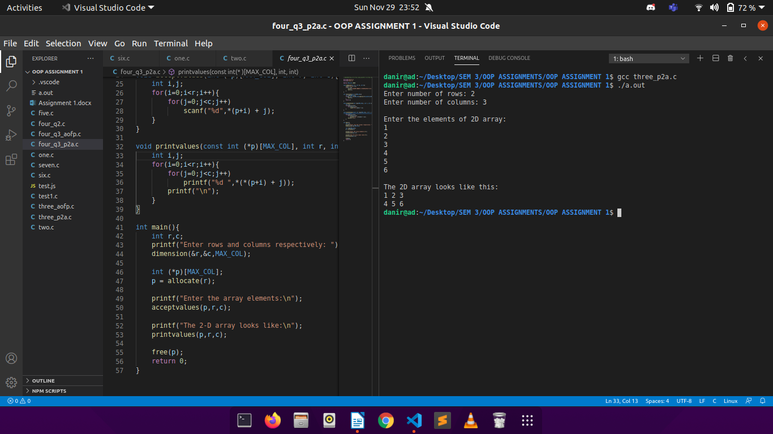

Q4a.

CODE:

// implementing 1-D array using single pointer and functions

#include<stdio.h>

#include<stdlib.h>

void dimension(int *n){

scanf("%d",n);

}

void allocate(int **p, int n){

*p=(int *)malloc(n*sizeof(int));

}

void acceptvalues(int *a, int n){

int i;

for(i=0;i<n;i++){

scanf("%d",a+i);

}

}

void printvalues(int *a, int n){

int i;

for(i=0;i<n;i++){

printf("%d ",*(a+i));

}

printf("\n");

}

void FREE(int *p){

free(p);

}

int main(){

int n;

printf("Enter array size: ");

dimension(&n);

int *p;

allocate(&p,n);

printf("Enter the values in array:\n");

acceptvalues(p,n);

printf("The 1-D array looks like:\n");

printvalues(p,n);

FREE(p);

return 0;

}

OUTPUT:

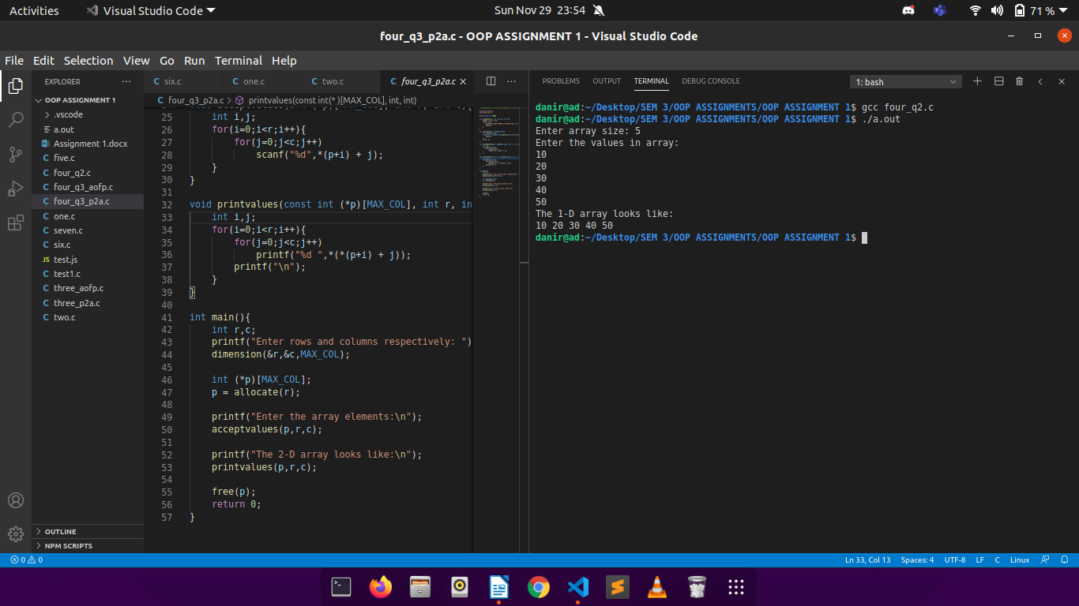

Q4b.

CODE:

//implementing 2-D array using array of pointers and functions

#include<stdlib.h>

#include<stdio.h>

void dimension(int *r, int *c){

scanf("%d %d",r,c);

}

void allocate(int ***p){

*p=(int **)malloc(100*sizeof(int *));

}

void acceptvalues(int **p, int r, int c){

int i,j;

for(i=0;i<r;i++){

p[i]=(int *)malloc(c*sizeof(int));

for(j=0;j<c;j++)

scanf("%d",*(p+i) + j);

}

}

void printvalues(int **p,int r,int c){

int i,j;

for(i=0;i<r;i++){

for(j=0;j<c;j++)

printf("%d ",*(*(p+i) + j));

printf("\n");

}

}

void FREE(int **p, int r){

int i;

for(i=0;i<r;i++){

free(p[i]);

}

free(p);

}

int main(){

int r,c;

printf("Enter row and column number respectivey: ");

dimension(&r,&c);

int **p;

allocate(&p);

printf("\nEnter the elements of 2D array:\n");

acceptvalues(p,r,c);

printf("\nThe 2D array looks like this:\n");

printvalues(p,r,c);

FREE(p,r);

return 0;

}

OUTPUT:

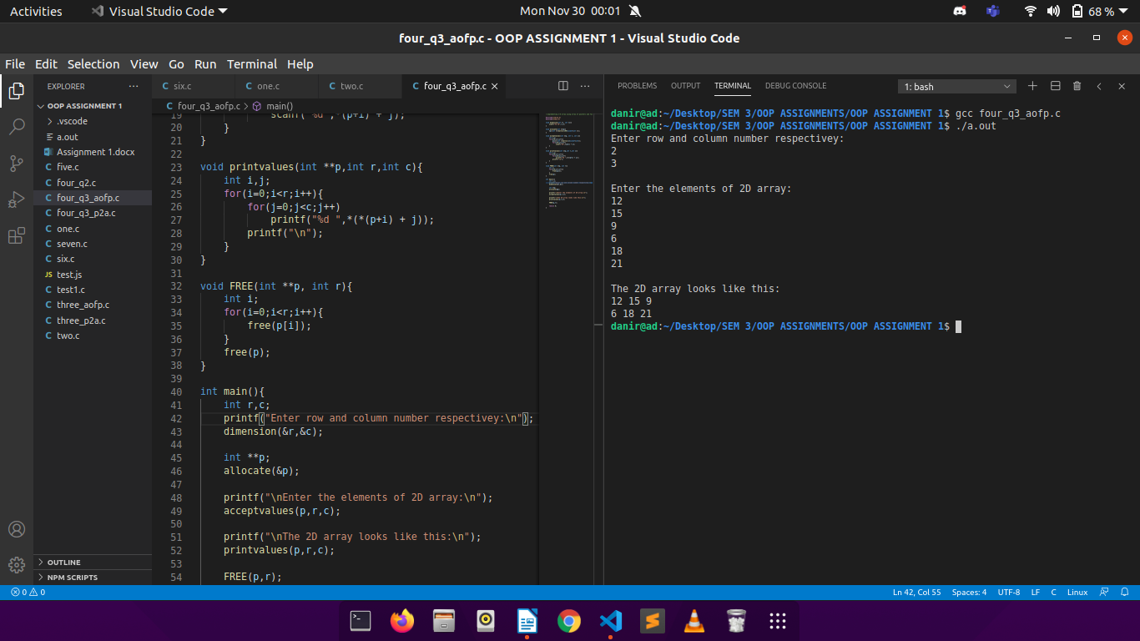

Q4c.

CODE:

//implementing 2-D array using pointer to array and functions

#include<stdlib.h>

#include<stdio.h>

#define MAX_COL 10000

void dimension(int *r, int *c, int C){

scanf("%d %d",r,c);

if(*c > C){

printf("COLUMN NUMBER IS RESTRICTED TO %d !!!\n",C);

exit(1);

}

}

int (*allocate(int r))[MAX_COL]{

int (*p)[MAX_COL];

if((p= (int (*)[MAX_COL])malloc(r*sizeof(int[MAX_COL]))) == NULL ){

exit(1);

}

return p;

}

void acceptvalues(int (*p)[MAX_COL], int r, int c){

int i,j;

for(i=0;i<r;i++){

for(j=0;j<c;j++)

scanf("%d",*(p+i) + j);

}

}

void printvalues(const int (*p)[MAX_COL], int r, int c){

int i,j;

for(i=0;i<r;i++){

for(j=0;j<c;j++)

printf("%d ",*(*(p+i) + j));

printf("\n");

}

}

int main(){

int r,c;

printf("Enter rows and columns respectively: ");

dimension(&r,&c,MAX_COL);

int (*p)[MAX_COL];

p = allocate(r);

printf("Enter the array elements:\n");

acceptvalues(p,r,c);

printf("The 2-D array looks like:\n");

printvalues(p,r,c);

free(p);

return 0;

}

OUTPUT:

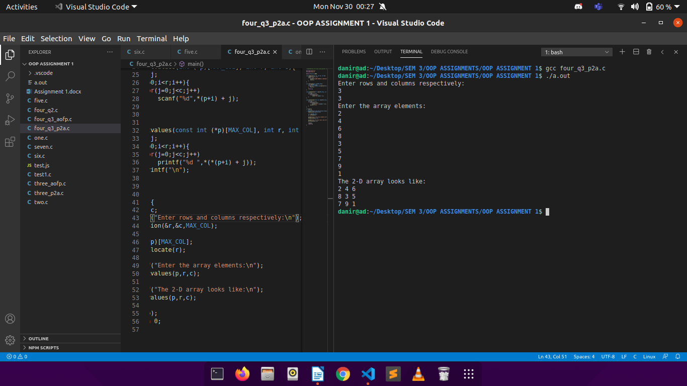

Q5.

CODE:

//implementing list of students without a structure

#include<stdio.h>

#include<string.h>

void readData(char name[][31],int age[],int n){

printf("Enter Names & Ages:\n");

int i;

for(i=0;i<n;i++){

scanf("%s",name[i]);

scanf("%d",&age[i]);

}

}

void sortAge(char name[][31],int age[], int n){

char ar[31];

int i,j,temp;

for(i=0;i<n-1;i++){

for(j=0;j<n-i-1;j++){

if(age[j]>age[j+1]){

temp=age[j];

age[j]=age[j+1];

age[j+1]=temp;

strcpy(ar,name[j]);

strcpy(name[j],name[j+1]);

strcpy(name[j+1],ar);

}

}

}

}

void printData(char name[][31],int age[], int n){

printf("The data in ascending order of age is as follows:\n");

int i;

for(i=0;i<n;i++){

printf("%s %d\n",name[i],age[i]);

}

}

int main(){

char name[100][31];

int age[100];

int n;

printf("Enter number of persons: ");

scanf("%d",&n);

readData(name,age,n);

sortAge(name, age, n);

printData(name, age, n);

return 0;

}

OUTPUT:

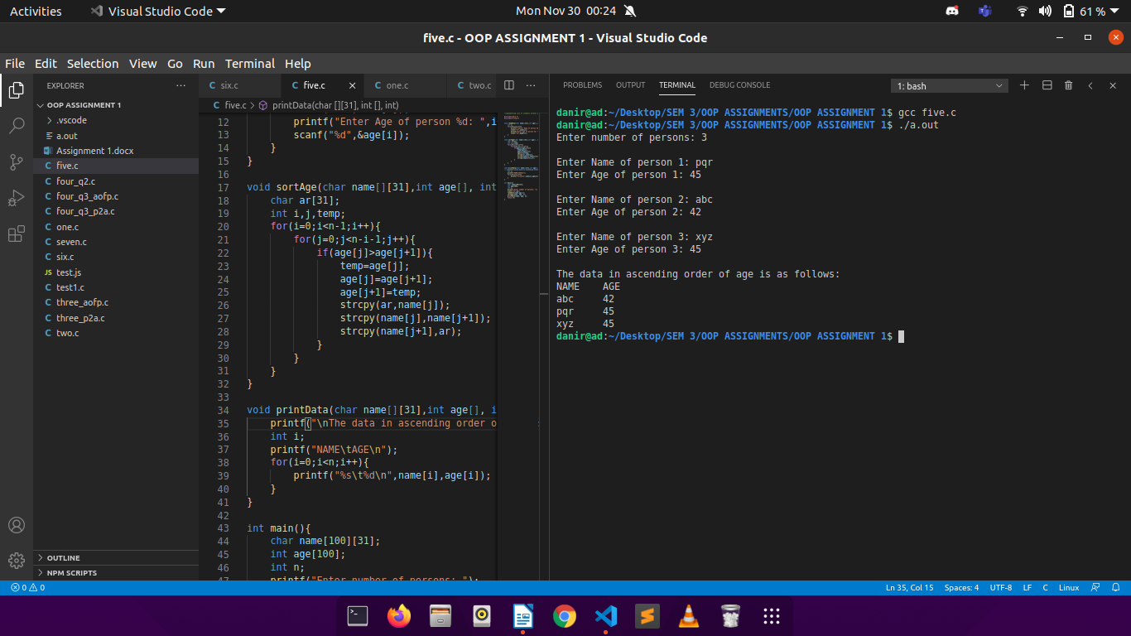

Q6.

CODE:

//implementing list of students using a structure

#include<stdio.h>

struct student {

int age;

char name[100];

};

void readData(struct student l[], int n){

int i;

for(i=0;i<n;i++){

printf("Enter Name of Student %d: ",i+1);

scanf("%s",l[i].name);

printf("Enter Age of Student %d: ",i+1);

scanf("%d",&l[i].age);

printf("\n");

}

}

void sortAge(struct student l[], int n){

struct student t;

int i,j;

for(i=0;i<n-1;i++){

for(j=0;j<n-i-1;j++){

if(l[j].age>l[j+1].age){

t=l[j];

l[j]=l[j+1];

l[j+1]=t;

}

}

}

}

void printData(struct student l[], int n){

printf("The data in ascending order of age is as follows:\n");

int i;

for(i=0;i<n;i++){

printf("%s %d\n",l[i].name,l[i].age);

}

}

int main(){

int n,i;

printf("Enter number of students: ");

scanf("%d",&n);

struct student ar[n];

readData(ar, n);

sortAge(ar, n);

printData(ar, n);

return 0;

}

OUTPUT:

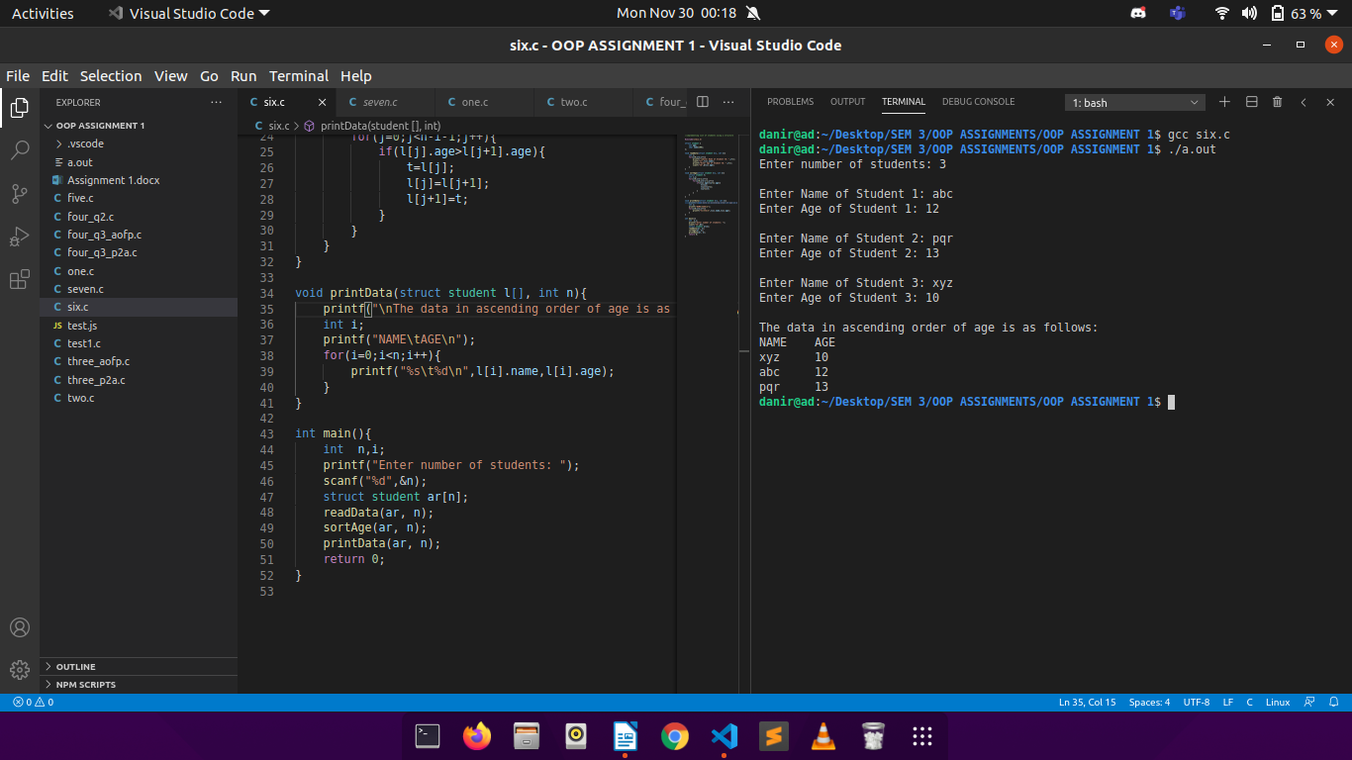

Q7.

CODE:

#include<stdio.h>

#include<stdlib.h>

typedef struct {

int roll;

char name[31];

int marks;

} student;

struct node{

student s;

struct node *adr;

};

struct node *root;

struct node* createnode(struct node **);

void addstudent(struct node *, int);

void display();

struct node *createnode(struct node **temp){

*temp=(struct node*)malloc(sizeof(struct node));

return *temp;

}

void addstudent(struct node *temp, int i){

printf("Enter the roll of student %d:\n",i);

scanf("%d",&temp->s.roll);

printf("Enter the name of student %d:\n",i);

scanf("%s",temp->s.name);

printf("Enter the marks obtained by student %d:\n",i);

scanf("%d",&temp->s.marks);

}

void del() {

struct node *ptr=NULL;

struct node *prev=NULL;

struct node *current=NULL;

int roll_no;

printf("Enter Roll Number to Delete:\n");

scanf("%d",&roll_no);

if(root->s.roll == roll_no){

struct node *tmp;

if(root == NULL)

printf("LIST EMPTY ALREADY!!\n");

tmp = root;

root = (root)->adr;

free(tmp);

}

else{

prev=root;

current=root;

while(current->s.roll!=roll_no){

prev=current;

current=current->adr;

}

prev->adr = current->adr;

current->adr=NULL;

free(current);

}

printf("Recored Deleted\n\n");

}

void display() {

struct node *temp;

temp=root;

printf("ROLL NAME MARKS\n");

while(temp) {

printf("-> %d %s %d " , temp->s.roll, temp->s.name, temp->s.marks);

temp=temp->adr;

}

printf("\n");

}

int main(){

int n,i;

struct node *p;

printf("ENTER NUMBER OF STUDENTS: ");

scanf("%d",&n);

for(i=0;i<n;i++){

struct node *temp;

temp = createnode(&temp);

addstudent(temp,i+1);

if(root==NULL){

root=temp;

p=temp;

}

else{

p->adr=temp;

p=temp;

}

}

p->adr=NULL;

printf("\nTHE LINKED LIST LOOKS LIKE THIS:\n");

display();

printf("\nWANT TO DELETE A RECORD? PRESS 1.\n");

int ch;

scanf("%d",&ch);

while(ch==1){

if(root==NULL){

printf("LIST EMPTY ALREADY!!\n");

break;

}

del();

display();

printf("\nWANT TO DELETE MORE? PRESS 1 TO CONTINUE AND 0 TO STOP!\n");

scanf("%d",&ch);

}

printf("\nFINAL LIST LOOKS LIKE THIS:\n");

display();

return 0;

}

OUTPUT:

